GSU Follow Up Email

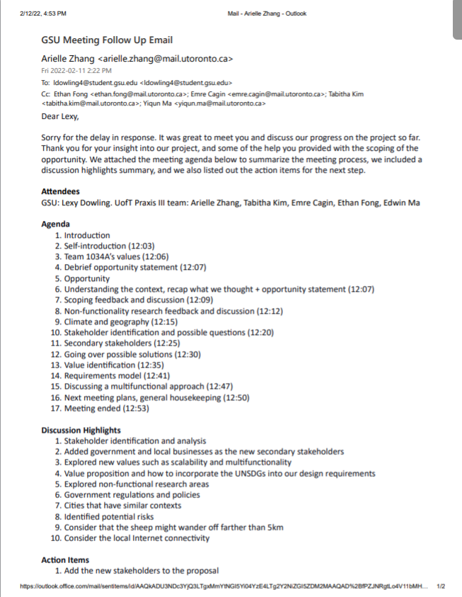

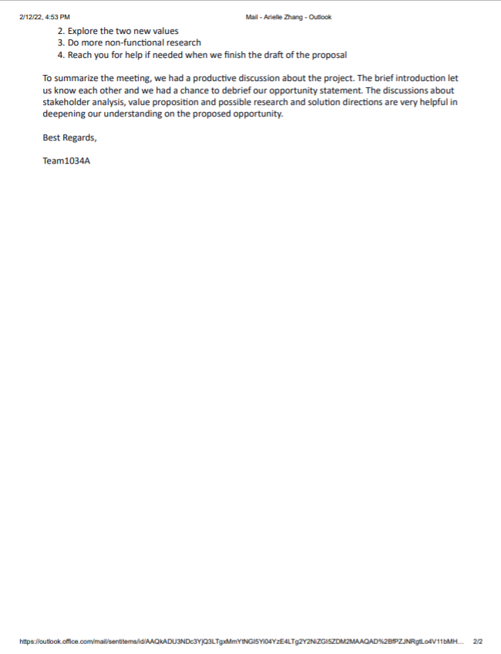

We need:

**Meeting Agenda (done)**

**Meeting summary (done)**

**Discussion Highlights (done)**

**Action Items**

**Attendees (Done)**

Dear Lexy,

It was great to meet you and discuss our progress on the project so far. Thank you for your insight into our project, and some of the help you provided with the scoping of the opportunity. We attached the meeting agenda below to summarize the meeting process, and we also included a discussion highlights summary.

Agenda

1. Introduction
   1. Self-introduction (12:03)
   2. Team 1034A’s values (12:06)
   3. Debrief opportunity statement (12:07)
2. Opportunity
   1. Understanding the context, recap what we thought + opportunity statement (12:07)
3. Scoping feedback and discussion (12:09)
4. Non-functionality research feedback and discussion (12:12)
   1. Climate and geography (12:15)
5. Stakeholder identification and possible questions (12:20)
   1. Secondary stakeholders (12:25)
6. Going over possible solutions (12:30)
7. Value identification (12:35)
8. Requirements model (12:41)
   1. Discussing a multifunctional approach (12:47)
9. Next meeting plans, general housekeeping (12:50)
10. Meeting ended (12:53)

Discussion highlights

1. Stakeholder identification and analysis
   1. Added government and local businesses as the new secondary stakeholders
2. Explored new values such as scalability and multifunctionality
3. Value proposition and how to incorporate the UNSDGs into our design requirements
4. Explored non-functional research areas
   1. Government regulations and policies
   2. Area that has similar contexts
5. Identified potential risks
   1. Consider that the sheep might wander off farther than 5km
   2. Consider the local Internet connectivity

To summarize the meeting, we had a productive discussion about the project. The brief introduction let us know each other and we had a chance to debrief our opportunity statement. The discussions about stakeholder analysis, value proposition and possible research and solution directions are very helpful in deepening our understanding on the proposed opportunity.

Action Items

1. Add the new stakeholders to the proposal
2. Explore the two new values
3. Do more non-functional research
4. Reach you for help if needed when we finish the draft of the proposal

Attendees

GSU: Lexy Dowling. UofT Praxis III team: Arielle Zhang, Tabitha Kim, Emre Cagin, Ethan Fong, Edwin Ma

Best Regards,

Team1034A

the basic concepts of the problems that we are facing. We briefly went through all the questions, and she gave us some important points for the questions like we can add more values into considerations. The meeting is very helpful to us and for the next time, we will show her some possible solutions that we made and let her help us to select.

• Value Proposition   
o How well has the team articulated the value of their proposed design,   
the approach for achieving this design and what it might provide for   
the various stakeholders?

Went over the requirements, she said we did a pretty good job.

What did she ask?

o What would you recommend that the team think about or pay   
attention to going forward (especially as it relates to providing value   
and aligning these with the UN SDGs - <https://sdgs.un.org/goals>)?

Recommendations:

What would we do if the go beyond 2 km?

* Add points here

In addition to these points, some of the action items that we identified

Many Thanks,

Team 1034A

Meeting Agenda:

Introduce to each other

* Self-introduction
* Teams values
* Communication/working styles

Opportunity statement

* Use the opportunity statement
* Possible Framings/possible value propositions
* Any questions?

Stakeholder Identification   
o How well has the team explored who the main external stakeholders   
(focus on plural) are?

o Are there other important external stakeholders the team could   
consider?

She said we did a pretty good job, look good to her

Secondary Stakeholders:

* Government policy making: convince citizens to use it
* Local business, might be affected in terms of profit
* Find locations that have similar contexts for non-functionality research

• Value Identification   
o How well has the team explored the various kinds of value that can be   
provided to these stakeholders?

Talked about SDG values, she said we did very well in exploring the values

Scalability, would the government be able to use this for other livestock?

To gain support from the government

Multifunctional for sustainability purpose also aligns with the UNSDG goals

o Are there other kinds of value that can be provided that the team could   
consider?

Again multifunctional

Has to identify the impact of the issue, other wise government will not help regulate.

• Value Proposition   
o How well has the team articulated the value of their proposed design,   
the approach for achieving this design and what it might provide for   
the various stakeholders?

Went over the requirements, she said we did a pretty good job.

What did she ask?

o What would you recommend that the team think about or pay   
attention to going forward (especially as it relates to providing value   
and aligning these with the UN SDGs - <https://sdgs.un.org/goals>)?

Recommendations:

What would we do if the go beyond 2 km?